Get your Rodeo (Dog!) On!!!
Trillium Valley Dog Training and Mahogany Ridge will be holding 2 Rodeo Dog Seminars with Mary Martin and Elaine Mayowski two of the founders of Rodeo Dog Company!
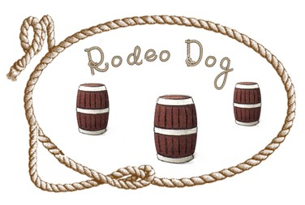
June 29th, 2024
1st Seminar 9:00 – 11:00, 2nd Seminar 11:30 – 1:30
Fun Match 1:30 – 3:00
Pre-registration required, closing date: June 24, 2024
Working spots are $50/handler and one dog. Auditors – no dog - $20.00
Seminars will be held at Mahogany Ridge in Culpeper, VA
For more information and to register, email: trilliumvalley@verizon.net or call 540-987-9632

